**HackInstead : Portfolio Website Plan**

Dillon Bendig, Team : Ridin’ Solo

**Idea:**

To use the hackworks, hackinstead, allocated time and resources to develop my own personal website using HTML and CSS. The goal for this project will be to have a finished website that I can use for networking and as an online portfolio for my projects and credentials.

**Key Functionality:**

* All buttons and links must work
* Clean and finished look(i.e. No skewed images or misplaced text or incomplete content)
* Toolbar that displays each section as tabs, clicking the tabs takes you to that point in the vertical translation down the page
* Has the following sections; About Me, Portfolio, Contact
  + Viewer is able to seamlessly scroll down the page through the sections
* Links to my GitHub and LinkedIn

**Additional Functionality(Extra time):**

* “Back to top” that returns the viewer to the top of the page
* Clear and aesthetic colour palette
* Contact box where the viewer can enter a message with a subject and send an email to an inbox from the webpage
* Make the webpage adjustable in size for different window sizes
* Make the webpage browser friendly outside of chrome
* Figure out how to get a domain and make the website accessible to everyone

**Development Steps:**

1. Complete Plan
2. Sketch out blue print for website design
3. Create project in atom, start read.me, get set up code in the HTML file
4. Develop main page for the website, has basis for the title and toolbar
5. Tool bar links work under testing conditions, moves you down throughout the web page
6. Choose designs for tabs, font, text style and overall aesthetic appeal -- implement headers for subsections to add these
7. Add additional content; images, links for github and linkedin, maybe instagram as well
8. Test and debug
9. Voice Over & Submit

**Schedule**

**\*DEADLINE SUNDAY @ 5PM\***

|  |  |  |
| --- | --- | --- |
| **Friday** | **Saturday** | **Sunday** |
| -Steps 1, 2, and 3  Update GitHub Repo | -Steps 4, 5 and 6  Update GitHub Repo | -Steps 7, 8 and 9  Update GitHub Repo |

**Webpage Sketch**

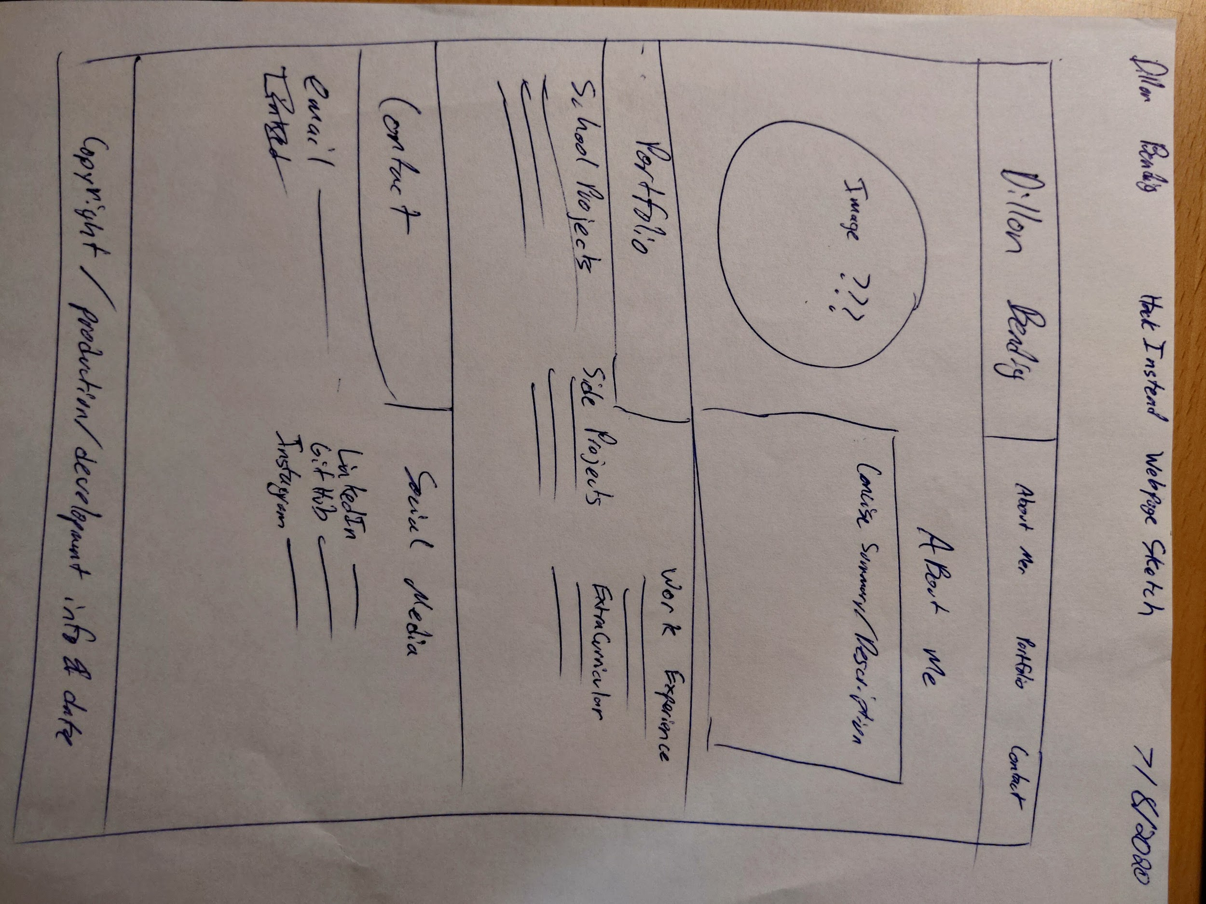

**Voice Over/Pitch Script**

Hello, my name is Dillon Bendig, and I am on my own team for the hackinstead hackathon. This is my first ever hackathon so I wanted to use the time and resources to really understand what it is all about. I decided to make a website from scratch using HTML and CSS for my project submission. My website is a simple, concise, but finished and functional online web portfolio for my personal achievements and experience. I decided to do this because I think it is very applicable, and I will be continuously building and improving off of this starting structure. Firstly, please make sure you have downloaded all files in the repository, as the images are also located there. Additionally, this webpage is currently only optimized for Google Chrome in a full-screen browser view. One of my extension goals was to make the website adaptable to screen size, however I ran out of time. As previously stated this website is simplistic in its design, and concise with its information display to the user. Before I began development, I wanted to create a thorough planning document for this project. The planning document can be found in the repository, and it includes; key functionalities, my development process, scheduling of tasks, and of course my rough sketch of the web page. When designing this website it was important to me that it was all one seamless page, rather than tabs that would take the user to different pages. This is primarily because of user-friendly interface design. With my current design the user can choose to scroll down through the entire website, or select buttons at the top that will transport the user to the requested section on the page. For aesthetic appeal, and differentiation of sections, I used different background images for each part. This allows the user to subconsciously recognize when they have entered a different section within the webpage. After design, core functionality was the next priority for me, I wanted to ensure that all the links to my various accounts on other platforms like GitHub and LinkedIn, were working perfectly. All in all I am happy with what I have produced by myself in the given amount of time, and I believe it was a good starting point to show myself what I am capable of under short term planning and development. I appreciate the opportunity to take part in HackInstead, and I was impressed with the support and resources offered by the Hackworks team. Thank you for your time.